*Artificial Intelligence (M.Tech)*

# First and last name

# Question 1/6 *(1 p.)*

The Data structure used in standard implementation of Breadth First Search is?

A. Stack

B. Queue

C. Linked List   
D. Tree

# Question 2/6 *(1 p.)*

A person wants to visit some places. He starts from a vertex and then wants to visit every vertex till it finishes from one vertex, backtracks and then explore other vertex from same vertex. What algorithm he should use?

1. Depth First Search
2. Breadth First Search
3. A* Search
4. Greedy Best First Search

# Question 3/6 *(1 p.)*

What is the equation of Manhattan's Distance?

1. |(X2+X1)| + |(Y2+Y1)|
2. 
3. 
4. |(X2-X1)| + |(Y2-Y1)|

# Question 4/6 *(5 p.)*

Explain Adversial Search with pseudocode.

*Artificial Intelligence (B.Tech)*

# Question 5/6 *(12 p.)*

Write a python program implementing any Search strategy to solve the arrange square puzzle (Image below).

Your code should be able to solve the two puzzles attached (one.txt, two.txt)  
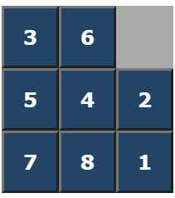  
NOTE – The code should be well formatted and explained with the help of comments wherever required.

Answer the following – (1 mark)

A – Which Search strategy implemented –

B – No. of steps taken –

C – No. of states explored –

Marking scheme for programming question -

3 marks – code

2 mark – above 3 questions

4 mark – formatting & commenting & understanding

3 mark – for applying heuristic